Kenny Darrell
Stochastic Modeling QA-760
Quarter Project

Simulations of The Gamblers Ruin Problem

The Gambler’s Ruin Problem is a type of Random Walk, which has states that move back and forth incrementally in any number of dimensions. The model to be considered here is one dimensional, with the states being restricted to X never having negative values, representing a bankroll for the given player. A basic gambling problem was considered, where there are always two players wagering a single unit each time step and a randomly generated variable deciding the winner. The states will be a player’s bankroll. This can be finite or infinite depending on the player, the house being infinite and a basic player being finite. The player under consideration will have finite bankrolls and will play under many different circumstances. He will always win if the generated value meets the logical expectation in the model. First he plays the house with different random number generators. He then plays another player with the same bankroll using different methods of for the given random number generator seeds. Next he will play another player but they will have varying starting bankrolls. This will be a case were there is a finite state space and theoretical solutions exist. I would like to run these models many times and collect data and see what I can gather from the data. If there exists a theoretical solution, compare that to large amounts of runs and see how they compare. In other cases I will look into the quality of the MatLab environment for simulating these types of problems, does the random number generator or seed method have an effect on the outcome. In any case I think that creating something, producing data, and analyzing is a very effective way of immersing yourself in a problem and helps in it’s understanding.

The platform will be a Simulink model. It will use a uniform random number generator, Uniform (0, 1), and a Gaussian distributed random number, Gaussian(μ=0, σ²=1). For the uniform case the player will win if his bet is higher than .5 and greater than or equal to 0 for the Gaussian. The value will be checked against a constant parameter stored as a type double to determine the winner. For all cases besides that of comparing the two, the uniform will be used. They generate numbers based off of a starting seed. The seed can vary in values from 0 to 2³²–1, the type double storage limit. For some cases the seed will be set by a counter and for others using a clock function. This will allow for cases that can be rerun to get the same number, the seed will increment in a loop. The other method will be time dependent, which will use the MatLab clock function times the ceiling value of a random number. This will allow looking at how the seed affects the generator. To track the states a player is in a counter will be used to add and subtract from players bankrolls and will stop when a player’s state reaches zero, goes broke. The simulation will be executed from a MatLab script. The script will set various starting bankrolls, opponent’s bankroll, and number of times to be run. It will also calculate various statistics of interest as well as generate plots for that case. The script can run a large number of simulations with the same conditions and take their averages’ and then increment a condition as to get a trend.

The problem that is being modeled can be seen in Figure 1, this version of the model has a finite state space. It represents the case were both players have a finite bankroll. It show’s how the to get form one state to another, flowing threw randomly based on the probability of winning and losing at each state, which remains the same, p and q respectively. You can also see that it has two absorbing states, 0 and H. These will refer to the player going broke, where his bankroll has been depleted, or achieving a bankroll of H, where his opponent having a finite bankroll went broke. Once inside these absorbing states they will remain there indefinitely as one player will no longer have any money to wager for the next game. One of the Simulink models that were used can be seen in Figure 2, Simulink Model of the Gambler’s Ruin Problem. All models that were used were basically the same with only a few minor adjustments for the specific case under consideration. This is the model that ran the both of the random number generators. You can see the random number generators are inside the boxes. The value is compared and sends out whether the player one or lost, which is just the random variable compared to a constant. Form there it moves on to determine whether to add or subtract a dollar to his bankroll. The bottom part is a little over complicated way of simulating an initial bankroll to add to the varying sum, but since the sum runs on a memory it needs a zero input after the first frame has run. It will run indefinably until the player goes broke. It also sends all time series data to the workspace. Then the simulation will stop handing execution back to the m file script that called it.
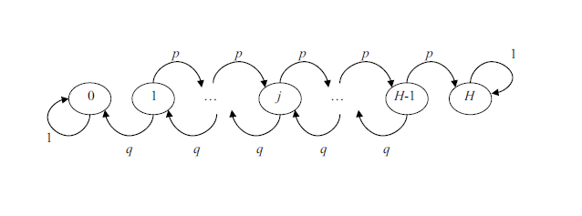
Figure 1, Gambler’s Ruin Model, Finite State Space, X_{t} = {0, H}

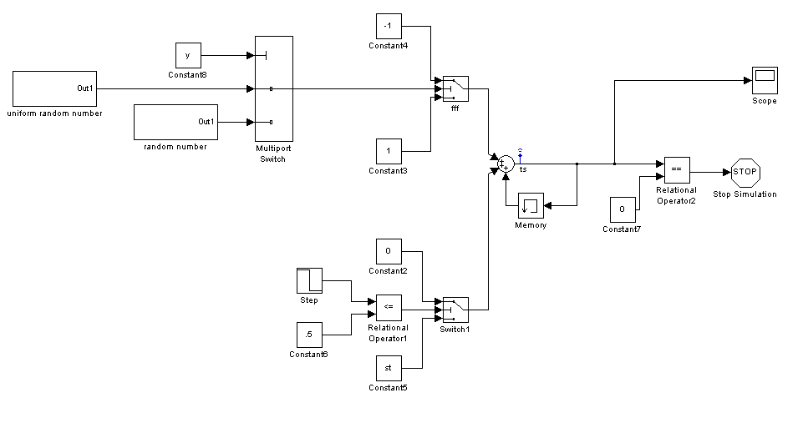
Figure 2, Simulink Model of the Gambler’s Ruin Problem

For the first case there were two random number generators under consideration as described above. In Figures 3 and 4 the plots of the first six runs are shown for each random number generator. Figure 3 shows the plots for the player starting with an initial bankroll of $10 and the house having an infinite bankroll. Figure 4 shows the same case but with a starting value of $15. From the plots you can see that both seem to be random. The difference in the starting values can also be seen in the corresponding seeds. Just from looking at the first graph in each set of plots you can see that it took 5 times as long to go broke. The first goes broke in 20 time steps and the second goes broke in approximately 100 time steps. Then 10 runs and 100 runs were simulated. The max value reached by the player and the time steps were averaged for both numbers of runs. For 10 runs the max value averages were 39 and 40 for uniform and Gaussian. The time averages were 2283 and 2286. The max value for 100 runs was 99 for both. The time averages were 9614 time steps for each. These were all done with a known random seed. Next I ran the same cases with a clock function giving the simulation a seed. These values can all be seen in Figure 5. The first run with the clock function using 100 runs actually caused my machine to crash, it used every available bit of virtual memory leaving none for the screen update. The second and third time I ran the script it worked without using all memory. The first thought I had while looking at these numbers was that they are different. The Uniform and the Gaussian are roughly the same for both numbers of runs and both seed generation methods, but the seed generation methods differ from each other. This would lead me to believe that there is a problem with using random number seeds that are known. Thus the runs with the clock are probably closer to the real values.

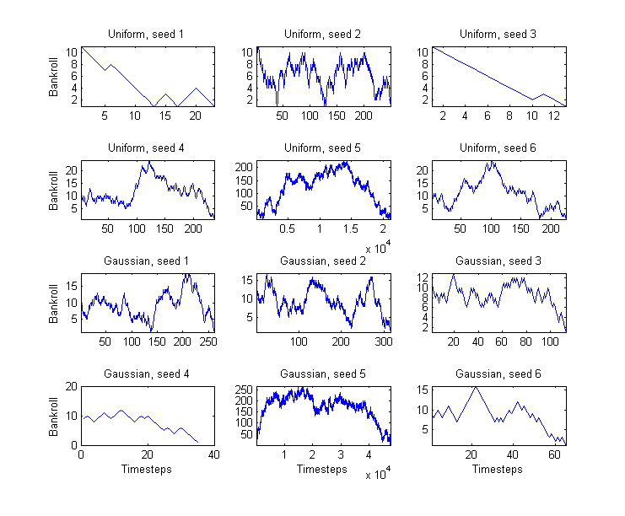
Figure 3, Gaussian vs. Uniform generators for Player having $10 Bankroll
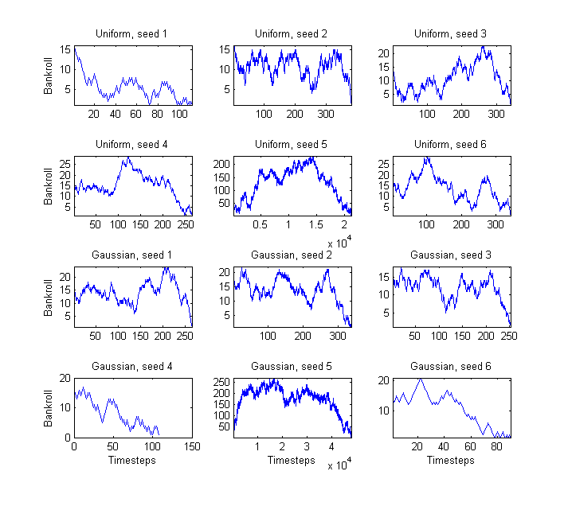
Figure 4, Gaussian vs. Uniform generators for Player having $10 Bankroll

Starting Value $10
 |  | 10 runs |  | 100 runs
 |  | Time | Max | Time | Max
Known seed | Gaussian | 2286 | 40 | 9614 | 99
 | Uniform | 2283 | 39 | 9614 | 99
Clock seed | Gaussian | 1099 | 42 | 5910 | 69
 | Uniform | 1532 | 31 | 5911 | 69
Figure 5, Data from the testing random number generators

The case that was run next was for the player playing another player with a finite bankroll. Their starting bankroll is the same. The figures 6, 7, 8, and 9 show the each players bankroll for varying starting values. The starting bankrolls are $10, $20, $30, and $100. From these plots you can see that time for a player to go broke increases as the starting values for each player increases. To find averaged 100 runs of each were ran and the times were averaged. These values were 101, 380, 930, and 9565. It is clear that the number grows very rapidly based on the starting bankrolls. From knowledge of probability and stochastic systems this seems intuitive, the more possible states that they can travel through would lead to a longer travel time before they are absorbed. Intuition aside, it is very interesting to see the values for actual cases. The win percentage of player A was also averaged. Player A won 47%, 45%, 50%, and 53% of the time for the different starting values. This value should converge to 50% if more runs were simulated, but as earlier I do not have the appropriate memory to go much farther than 100 runs. For a lower number of cases it should vary farther from 50%. Ten runs for each case were simulated next to see this change. The wins were 40%, 40%, 30%, and 30%. All of these are much farther from .5 and having more variance. This shows very well the law of large numbers for this stochastic model, the more times it runs the closer it gets to its theoretical value of the player winning exactly half of the time.

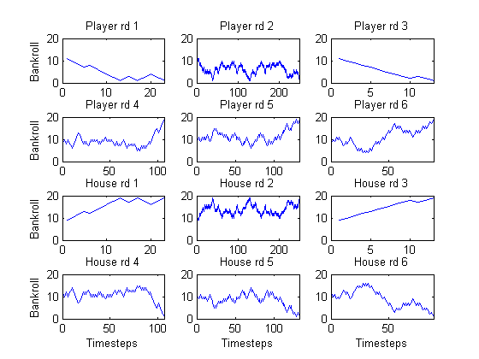
Figure 6, First six rounds starting bankrolls of $10
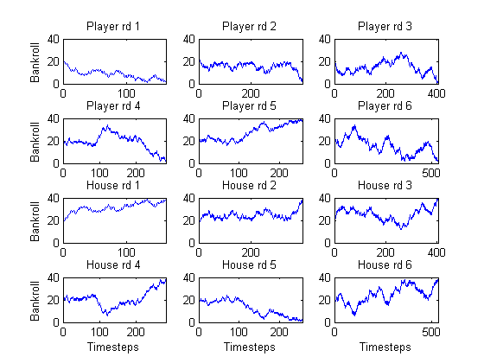
Figure 7, First six rounds starting bankrolls of $20

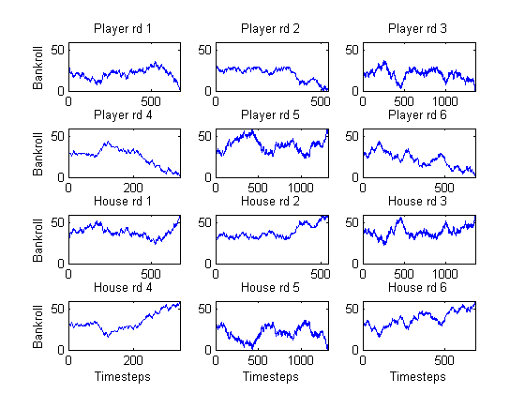
Figure 8, First six rounds starting bankrolls of $30

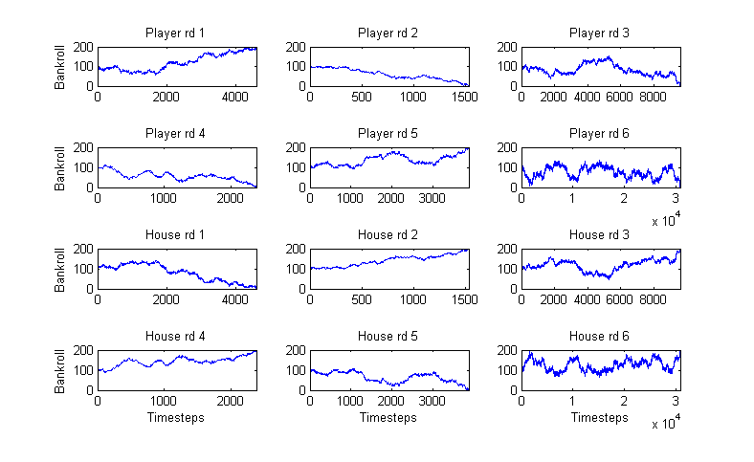
Figure 9, First six rounds starting bankrolls of $100
For the third case of running the model I decided to vary each players bankroll. Each player would start with set number bankroll and it would increase. The second players bankroll would remain constant for all of these runs and would increment only when the first player started over. I ran the same model at three different times and the plots are shown below in Figures 10-12. They each start with ten dollars and work there way up to $100. The plots show the value a player starts with times 10 on the axis, and the color scale is the time it took to finish. It shows how the model was dependent upon the clock function. The most interesting thing I noticed from these plots was that where each player started with $10 actually ran twice as long as any other in Figure 10. On the average this should be the fastest to complete, as there are less states for the players to bounce around in. They all took around the same time except the ones that go farther from blue; these getting closer to red took a lot longer to run. These plots were all run for only one game at each value, there was no averaging. Figure 13 varies from $15 to $150 to show the difference from the other cases. There is a very simple equation that describes this model. It is the probability of a player winning, P, is equal to his bankroll divided by the sum of both players bankrolls. I then ran different numbers of runs and averaged there wins and losses to see how it compared to the theoretical value of p = n1/(n1 + n2), where n1 and n2 are the players starting bankrolls. Player 2 will have a starting bankroll of $10 and Player 1 will vary from $1 to $50. This will give a low probability of winning to start, moving through equal to a greater chance. Figure 14-17 show these averages converging to the theoretical values. They averaged values of 20, 50, 250, and 500 trials of the same conditions. The one that ran to 500 only varied the values to $20 for time considerations. The values all seem to be converging but seem as though they would take more runs, but the trend is still very visible. The lower number of averaged values is very jagged but as they get higher they become more continuous.

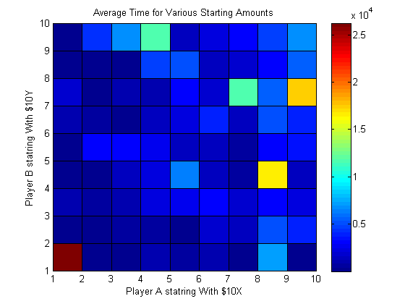
Figure 10, Ran at 8:33
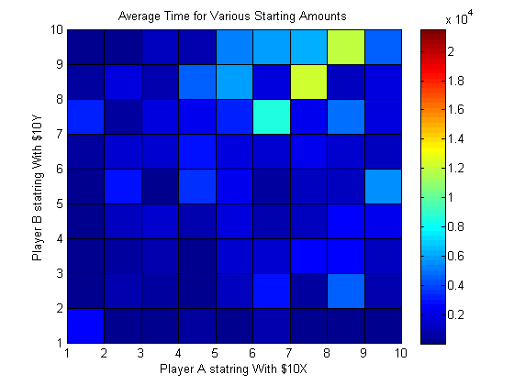
Figure 11, Ran at 8:34
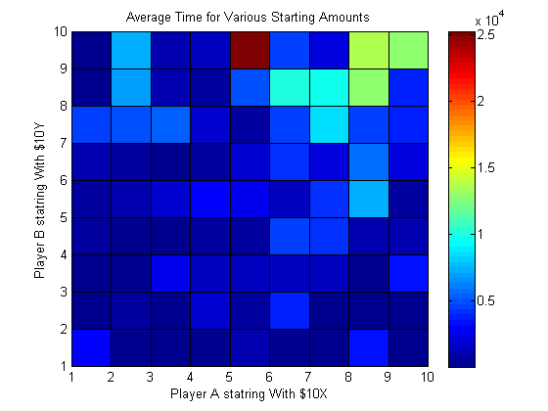
Figure 12, Ran at 8:35
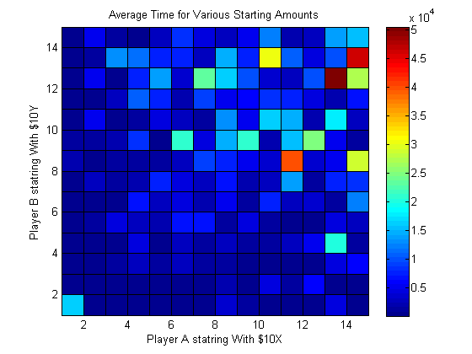
Figure 13, Players starting bankrolls varied from $15 to $150
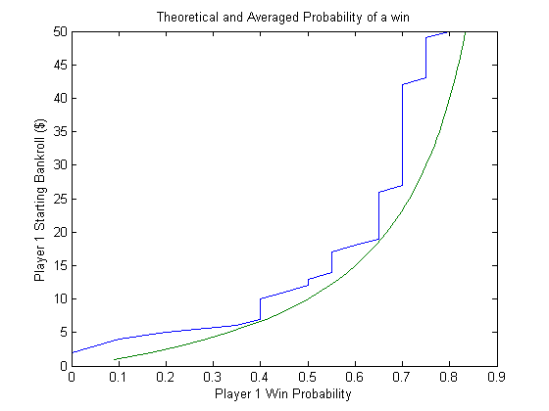
Figure 14, 20 Runs, varied to $50 starting bankroll
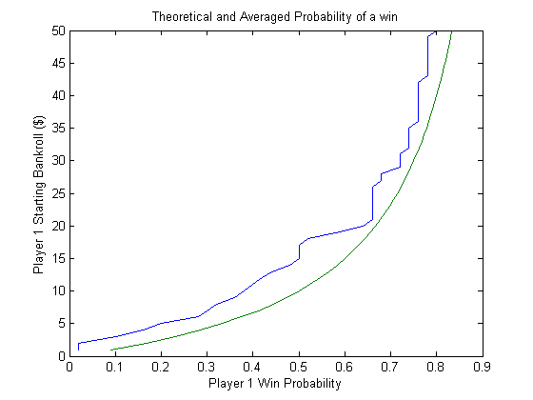
Figure 15, 50 Runs, varied to $50 starting bankroll
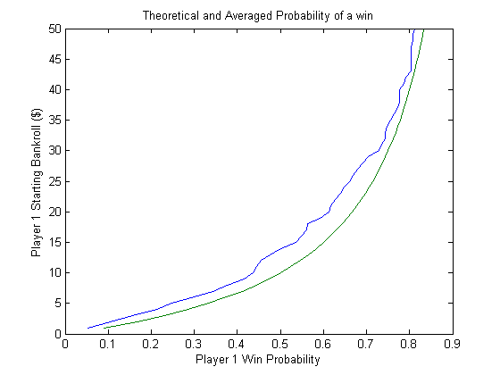
Figure 16, 250 Runs, varied to $50 starting bankroll
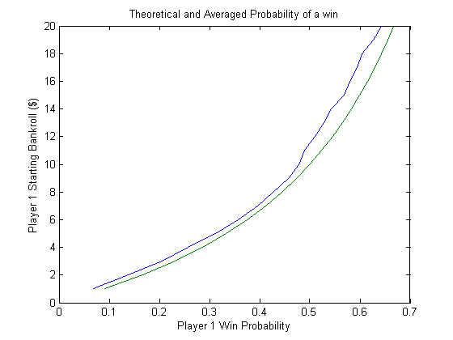
Figure 17, 500 Runs, varied to $20 starting bankroll

I think that the model being run under these conditions shows how a gamblers ruin problem really works. The theory states that if the player playing with a finite value will always lose to a player with an infinite value will always lose. This was true, every case finished in a finite amount of time, except to those than ran for a long enough time to kill the MatLab workspace memory. The cases that were ran a large number of times also seemed to stabilize around a value even under different considerations. Those that had theoretical solutions seemed to also be converging to this solution. The trial where the solution was plotted and different numbers of trials were averaged seemed to show this very well. It also leads me to believe that MatLab is an appropriate system to model these stochastic models. I think that this model could also be used to show various odds on the game and how they effect the outcome, as well as running the model under much more complex situations. Two players could play the house or a game were three players all played each other. Simulating these more complex games could give a lot of information of the underlying stochastic model.

